Lab 4 – Multiple Inheritance & Polymorphic Service Providers
Inheritance allows the reuse of state and behaviour by coupling a class to other types as part of the class definition. This is a compile-time activity & has major consequences for the design of loosely coupled object-oriented applications.
Inheritance creates transitive relationships and dependencies between dependencies in an inheritance hierarchy or graph. The relationship between abstraction, inheritance and polymorphism is also transitive, as the latter two concepts are directly derived from the first. Abstractions are highly reusable in a variety of different contexts and as classes become more specialised their degree of reuse becomes more restricted. From this context abstraction can be viewed as specialising abstract entities as concrete realisations and as a process of moving from the abstract to the specific
Inheritance underpins the concept of polymorphism or dynamic binding, where a method implementation is determined at run-time by the specific instance of a type being used.
Polymorphism recap – polymorphism in java is basically a task that does something but in a lot of different ways. i.e. deciding how to do something at runtime

Principle of Sustainability (POS) AKA Substitution Principle - SOLID
Fundamental Mechanism for inheritance in object-oriented languages.
Substitutability refers to the ability to dynamically assign to a variable of a given type an instance of another type, with no perceived difference in behaviour.
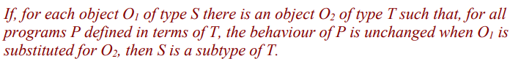
This implies that methods which use references to base types must also be able to use references to derived types without knowing the difference. Consequently, unless a class or method is marked as final or a class has been sealed, all method invocations are potentially polymorphic, i.e. the behaviour of a method depends upon the object instance that the method belongs to. Means that method signature i.e. visibility modifier, return type, name and parameters must conform to its original declaration.

NO INTERFACING IN FIRST ONE – PROBABLY NO DEADLY DIAMOND OF DEATH

